VAR Assessments

GNWT

6/23/2016
Jules Fournel
FS007 was ignited by lightning and has be free burning in C-2 fuel since June 20 and is being monitored. The fire made a substantial run on June 21 to the current MODIS size of 17,000 hectares. Several VARs are now threatened by the wildland fire.

  - VAR 293423
There is an NWTel communication tower located 3 km southwest of FS007. Mature C-2 fuel flanks the north, south, and east sides of the tower site. The ridge has a sharp drop on the west side of the site There is plenty of willow growth within the lease area but reduces in density as it encroached on the facility. The area immediately surrounding the VAR is low density fine fuel, low brush, and down to mineral soil in other areas.
Fuel tanks containing diesel, a generator and communication building, and communication tower are located near the center of the lease area. There are no requirements for sprinklers at this site as the VAR are metal and lack the fuels to carry a high intensity surface fire to the structures. Confidence level is high for the site to survive an approaching wildland fire given the lack of receptive fuels to produce a high intensity surface fire.
If prescribed burn is requested then a heli-torch would best be suited given the terrain which surrounds the NWTel site. The time required to prepare the site for a burnout operation would be three to five days with fire crews due the size of the leased area and heavy density of willows. Other consideration are the upslope on the north and east side which do not allow for a burnout from the edge of the lease. A line ignition 300’ to 500’ down from the top of the slope will provide a good uphill burnout and increase the defensible area around the site. This burnout operation could still produce similar fire conditions by just allowing the current fire to burn up to the NWTel site.

Overview of VAR and fuel type Lack of surface fuels to carry high intensity fire
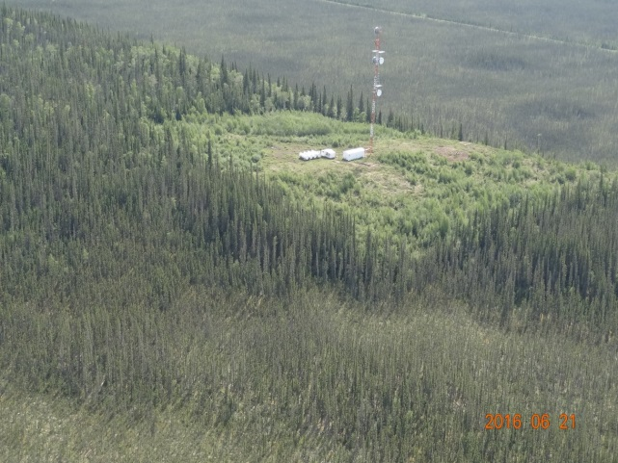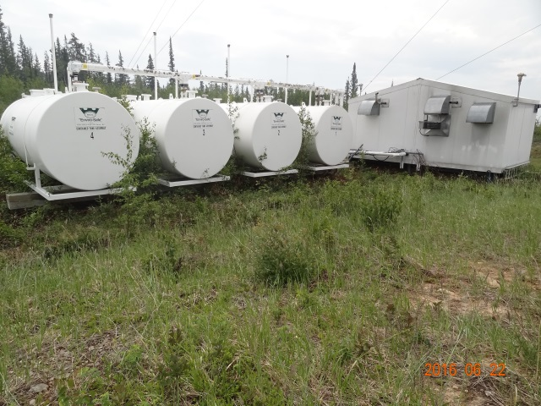

Tower base (mineral soil and low brush) Communication building (mineral soil & low brush)
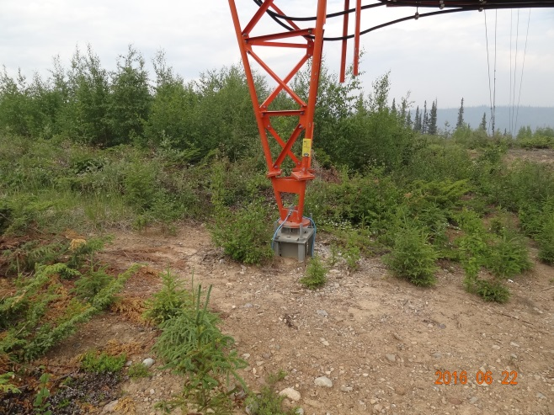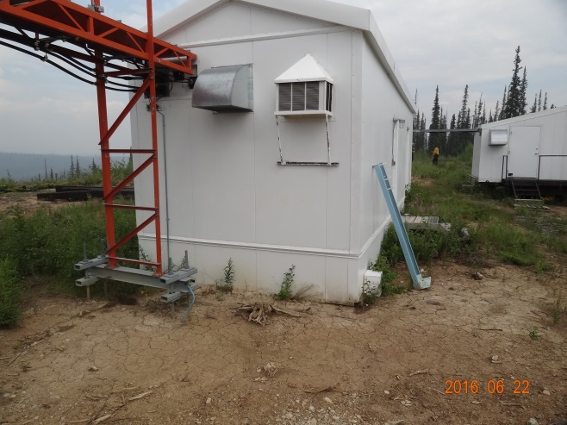

  - VAR 293301
The Enbridge Pipeline remote valve site is 5 km southwest of FS007. There is a communication tower, two large propane tanks, and a fiber glass building housing instruments at this site.
The area is surrounded by O-1 fuel and transitioning to willows as you move away from the facility. This remote valve site could be remediated by reducing the density of the fine fuel to reduce the surface fire intensity. The fence area encloses two large propane tanks and the fiber glass building. This area cannot be access by fire crews as it is lock. On June 23rd, fire crews slashed around the facility.
A burnout operation to remove the fine fuels from within and around the facility can be accomplished with hand torches and allow the fire to enter the surrounding forest to remove any future threats. Confidence level of success is high. Confidence level is also high in the event that the burnout operation does not happen prior to the wildland fire reaching the facility. Based on the surrounding fuel and building material of the structures on site, confidence level is high for the value at risk to withstand a low intensity surface fire.
SeaCan with oilspill response equipment Overview of remote valve site
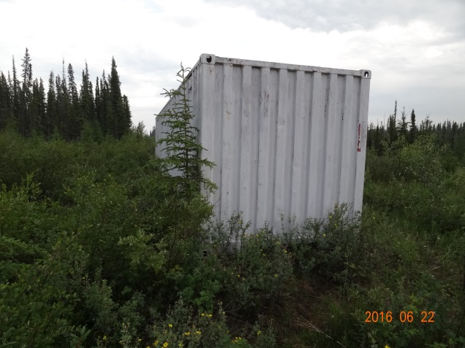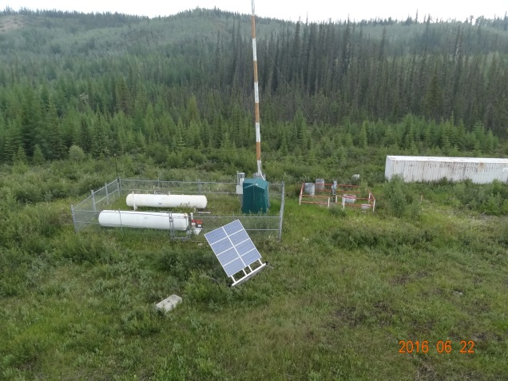
Fine fuels within the fence area C-2 fuel surrounding the site
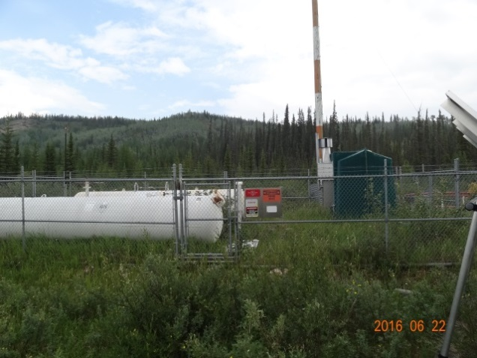
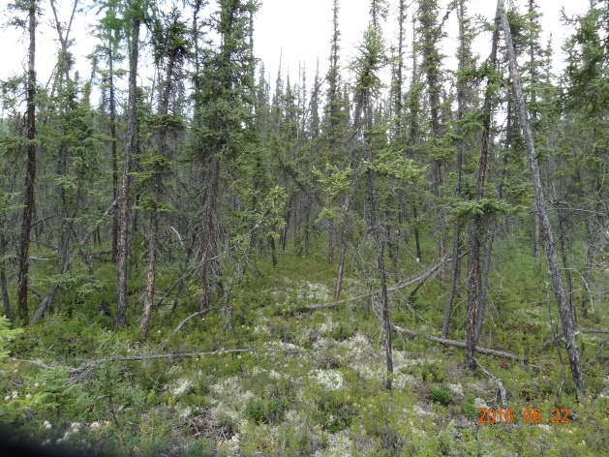
  - VAR 293297
An Atco camp is located within 5 km of FS007 and near the Enbridge Pipeline VAR. The camp site is surrounded by M-2 fuel (75% deciduous). The opening on which the camp is sitting is discontinuous fine fuels and mineral soil. This camp is well situated to survive an approaching wildland fire.
There are no requirements for a burn operation as the camp is protected from a direct crown fire. The M-2 fuel surrounding the camp will allow a crown fire to transition to a surface fire as it moves through the change in fuel type. There is a lack of receptive fine fuels within the clear area on which the camp is setup on to pose any direct fire threat to the trailers. Confidence for a successful clean burn operation is low.
The Atco trailers have sheet metal siding and sit approximately two and a half feet off the ground on steel sleigh runners. The roof is finished with an EPDM roofing membrane cover and is fire retardant specially formulated to inhibit the spread of fire.
Overview M2 fuel (75% deciduous) Discontinuous fine fuel and mineral soil
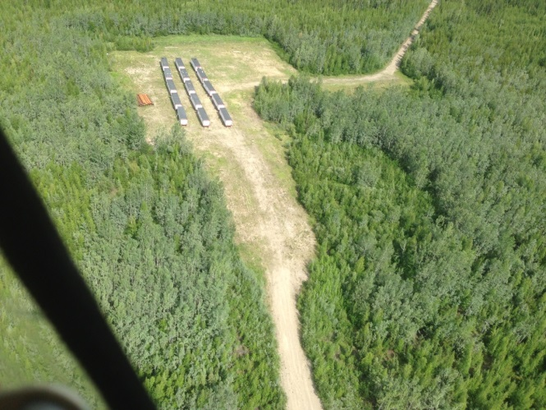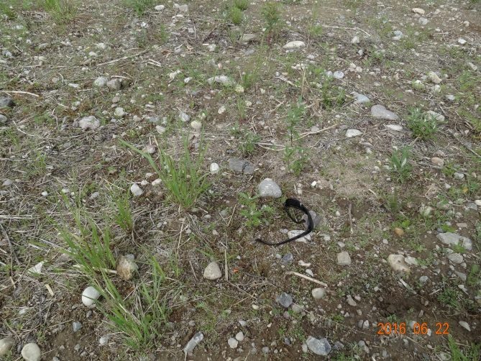
Forty to sixty year old forest (note burnt tree) Insufficient fuel to sustain surface fire
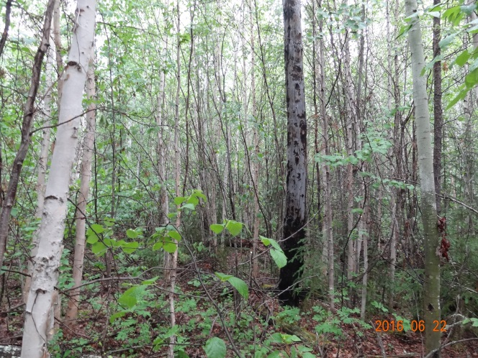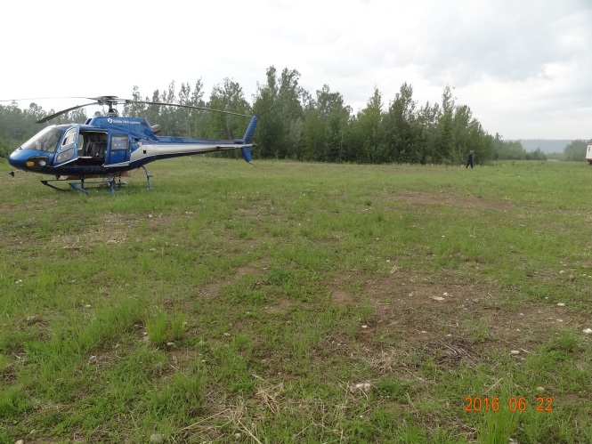
  - VAR 293417
The last VAR threatened by FS007 is a trapper cabin on the bank of the Mackenzie River. The cabin is surrounded by C-2 fuel. There appeared to minimal structures on the site other than the cabin.
A burnout operation would be required to protect the loss of the cabin to the wildland fire. Sprinklers would provide secondary support in case of a failed burnout operation. In the event of poor visibility , the site could be accessed by river to either set up a sprinkler system or carry on with the burnout operation if condition permit.
Fire crews have cut out a fuel break from which to conduct a burnout operation from will still leaving some green space around the cabin. Burnout operations can be carried out when conditions improve to ensure a successful burn.
Overview of cabin and fuel break Fuel break for burnout operation
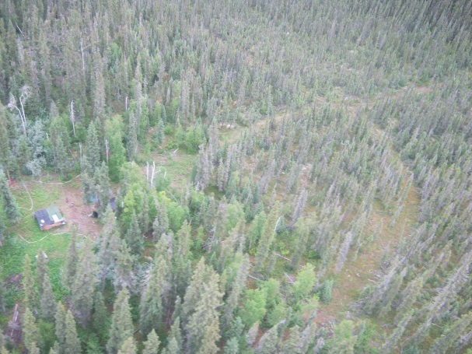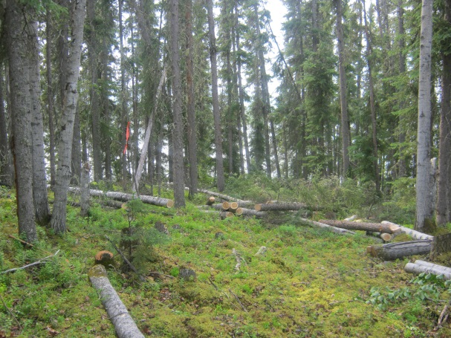

6/23/2016

