The northwest corner of the fire has a short run of unburnt fuel that can easily be tied into Great Slave Lake with a wind from any direction except east. There is a dozer line that will be used as a control line that will keep the fire from advancing towards the west.
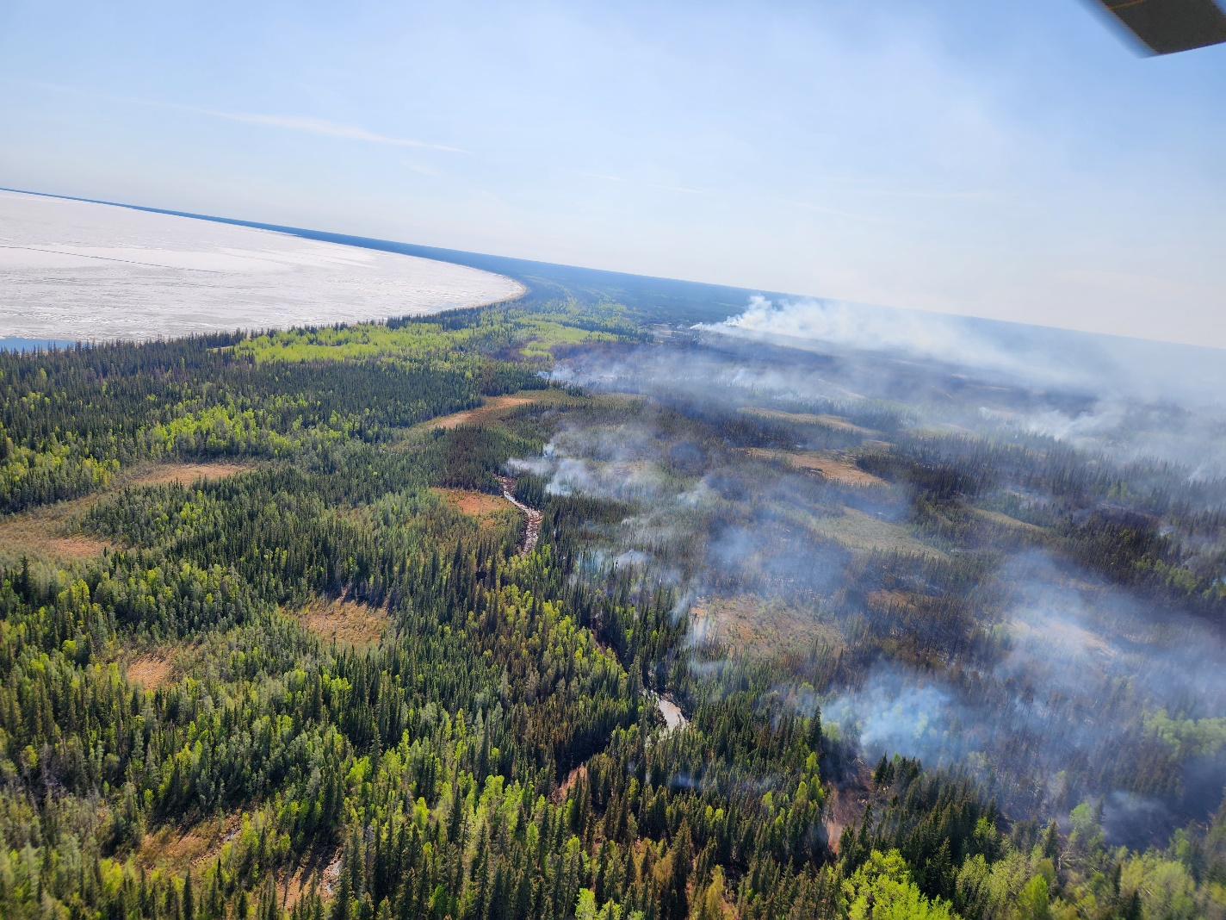
The picture above shows the fuel to east of the dozer line on the Norwest corner of SS005-23. The foreground shows the tightline dozer guard with the fire on the right.
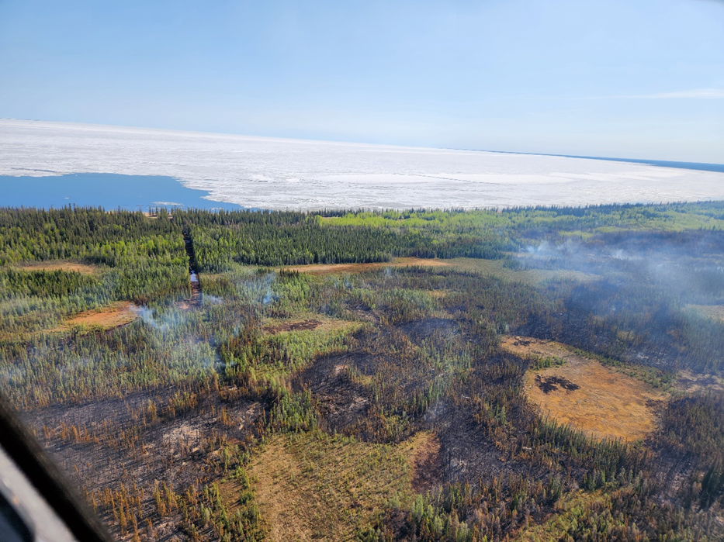
The picture above shows the dozer guard extending from the fire to the lake. The guard is not finished in this picture, but trust me, it’s now complete. This ignition operation can be carried out with either aerial ignition with a helitorch or PSD. This small line can also be burnt with hand held drip torches if the wind is favorable and there are crews to carry it out. This ignition operation will be carried out with a simple line ignition. If the wind is not directly from the west, the ignition will be carried out by starting either at the top or bottom and progress into the wind. Fire crews will be required to mop after the ignition has occurred.

There is a camp with 20 structures to the northeast of the fire at the mouth of Sandy Creek. There aren’t any natural features between the fire and the camp, therefore we will have to burn around the camp in order to protect it.
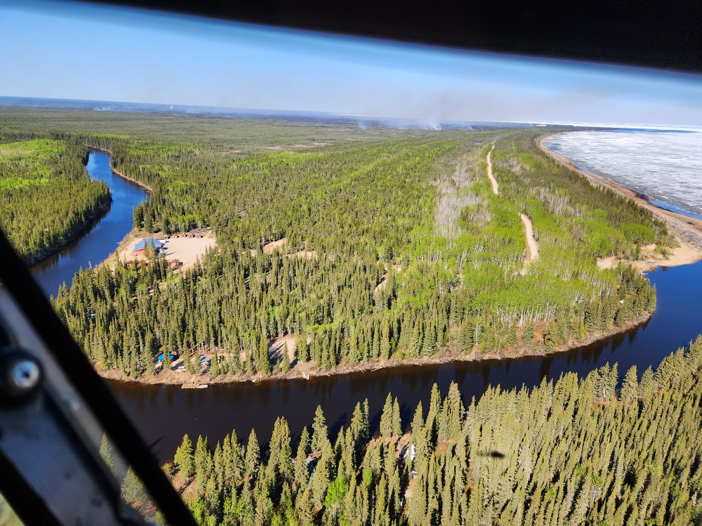
The picture above shows the camp at the mouth of Sandy Creek as well as the continuous fuel from the camp to the fire. There are structures on both sides of the creek, however the main camp is on the west side of the creek. If the fire is left to burn freely the camp will most likely be consumed by fire as well as the structures on the east side of the creek.
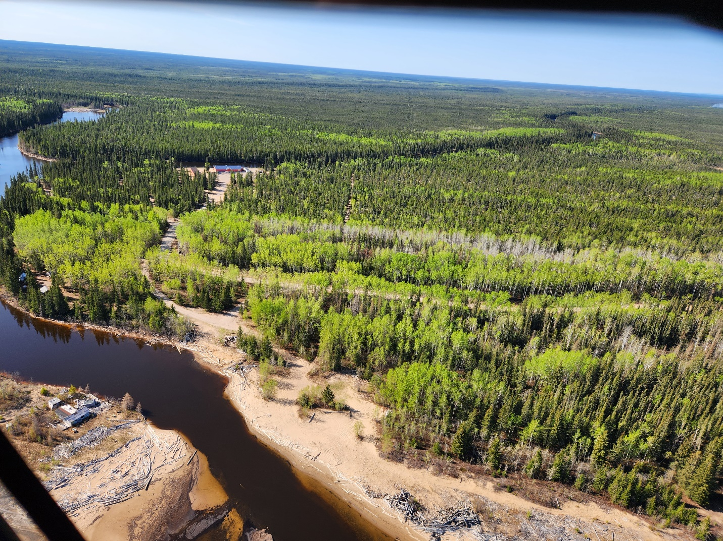
The picture above shows two options to burn from. The road is an obvious option, but a line must be cut from where the road meets the parking lot around the 5 structures on west side of the camp and tie into the creek. This will require a crew to cut the line and wet the east side of it down prior to ignition. It’s a good idea to have a crew stay at this location for at least 24 hours to conduct extensive mop up to ensure the fire doesn’t cross the ignition line. This ignition operation should be carried out with a wind that has an easterly component with hand held drip torches. Aerial ignition should be used to ignite a line about 100 feet from the road. Once the fire has had a chance to reach equilibrium a final line can be ignited from the ground along the road. The ignition line will go from the short of Great Slave Lake to Sandy Creek.

