PARADISE COMPLEX
Introduction
SS-0037 is currently 36,700 ha. Earlier suppression efforts based on the extreme fire behaviour and extreme fire weather conditions was indirect attack. A burn out was planned on the east side of the Hay River from Enterprise to Riverwood. 1st stage of the burn out was completed last Tuesday June 30th, 2015. The burn started at Enterprise as originally planned, ignition of the river side went right up to Paradise Gardens. Aggressive fire behaviour occurred around enterprise which carried the burn right to SS-0037 securing any advancement toward the community of Enterprise. Unfortunately conditions or the burn window closed not allowing the ignited banks of the last third of the way to Paradise Gardens to spread but rather create spot fires.
Current Fire Behaviour
Based on the precipitation at the fire and surrounding areas has received the activity on the fire is smoldering with occasional flare up if the area has dried for two days after a rain event. On Sunday June 5th, two reports of flare ups occurred. The dozer area called in for buckets to address some flare up around where the dozers were working. Another flare up also occurred on the SW corner of the fire. The SW corner is of less concern. These recorded flare ups show that it will only take minimal 2-days of minimal drying condition before the fuels surrounding the fire are available for intermittent crown fires in the C-2 with moderate spread.
Current Resources
IMT -12
Type 1 Crews – 4 Ontario (5 person); 1 NWT (5 person)
Dozer – 3
R/W – Two Intermediates IUX; SLY; Note – Region able to supply a medium r/w when necessary.

Suppression
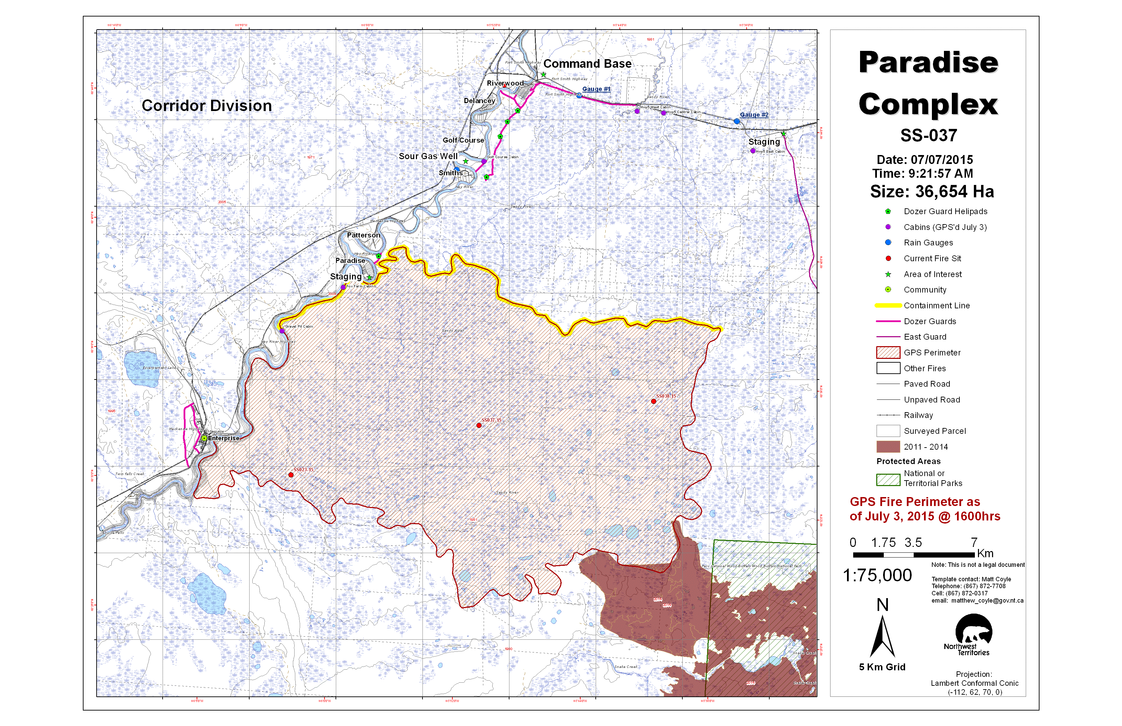
Highlighted in Yellow are the priorities for suppression.
- Ops and Plans scanned the north flank on Sunday June 5th, 2015 and found two areas with 1-3 hotspots. Division Supervisor Scott and a crew went to suppress them. Division Sup Beck will begin to walk the north flank beginning at the north east.
- Crews are mopping up the fireline across from Paradise and Patterson. Rapid Fire has set up their high volume pump to provide water to the crews for the mop up effort.
- On the Southwest corner two IA crews are working on hotspots from the river moving east approximately 1.5 km. This work will provide and anchor point to begin securing the south end of the fire. Further assessment of the South end for either direct attack or indirect attack will have to be decided once it is assessed. The region has reported two fires south of SS-0037 on apparently a spot fire and another modis fire. The region has proposed that they are not going to suppress those fires, if this is the case, then any proposed action on the south end of the fire would not be necessary as those two fires have high probability to burn all the fuel south of the fire.
- Further East on the south end at the last finger, the area will be assessed today to see if a catline can be put in place secure from the finger to the 2014 burn.
- It’s also proposed that we assess from the boundary division to push a cat line from the old road to the 2014 burn. This will assessment will be done today or tomorrow.
- The catguard from Riverwood moving south just past the sour gas wells is built as far south as possible. Ground conditions won’t allow dozers to move any further south and produce a useful guard.

THE PROPOSED CATLINES ARE MARKED WITH THE THICK BLACK LINE

Burnout
Burnout plans still continue but based on the attached Fire Behaviour assessment for the next 3-5 days. Conditions will not allow any clean burns.

Fire SS-037 Four Day Weather and Fire Behaviour Forecast For
Tuesday July 7 to Friday July 10, 2015

Weather:
Forecasts indicate that there may be a drying trend over the next four days with no significant precipitation predicted. A developing disturbance near Great Bear Lake and a building high pressure ridge south of the fire will create a tightening pressure gradient through the zone on Tuesday. Consequently, Tuesday is expected to be mainly sunny and dry with increasing winds throughout the afternoon into the early evening. There is also the possibility of a low level jet over the area as well. Maximum temperatures on Tuesday may reach the mid-20s and RH values will drop to near 30% by peak burn. The pressure gradient is expected to tighten Tuesday evening into Wednesday as a result of a strong advancing cold front and overnight recovery is expected to be poor.
Wednesday is expected to show minimum RH values in the low 30s with maximum temperatures in the mid to high 20”s. Winds will be brisk out of the WSW at 20km gusting to 30 before shifting to N 25km gusting to 45 by peak burn. The advancing frontal system is expected to pass over the area of the fire sometime Wednesday evening into Thursday morning, but at this time no significant precipitation is forecasted to accompany the frontal passage.
With the passage of the front, temperatures will drop into the low 20’s or high teens for Thursday and winds will return to a NW flow at 10km gusting to 20. RH values are expected to be in the 40% range under variable clouds.
A surface ridge moving into the area on Friday will bring a return to sunny weather with southerly winds and warmer and drier conditions.

Predicted Fire Behaviour:
If the forecasts hold and there is no significant precipitation on the fire during the forecast period, fire behaviour will continue to increase as fuels continue to dry out.
By Tuesday moderate fire behavior can be expected with class 3 fire behaviour predicted for C2 fuels by peak burn with some crown involvement possible if the fire is allowed to build momentum. C3 and grass/swamp fuels will still be limited to class 2 surface fires under the forecasted conditions. The forecasted winds may carry burning embers up to 200m but the probability of ignition is low for standing timber fuels and moderate for grass fuels. If spot fires do ignite in C2 fuels they may grow to 0.8 ha in an hour. If flare ups do occur on the fire, rates of spread by peak burn in C2 and grass/swamp fuels may reach 2 m/min, while C3 fuels while rates of spread in C3 will be 1 m/min or less. Spread direction for the fire on Tuesday will be to the east.
On Wednesday, class 5 fire behaviour potential will be possible in C3 fuels, class 4 in C3 and class 3 in grass/swamp fuels. Maximum rates of spread are forecasted to be 13m/min for C2, 5m/min for C3 and 12m/min in grass/swamp fuels. C3 will have continuous crown fire potential while C3 and grass fuels will be surface fires. Spotting distances will be 250m or more due to the brisk winds and the probability of ignition will be moderate. Spread direction will be to the NE at the beginning of the burning period, shifting to the S by peak burn.
Thursday will have slightly reduced fire behaviour from what is expected for Wednesday due to cooler temperatures, higher RH values and diminished winds. However, class 5 fire behaviour is still predicted for C2 fuels with rates of spread around 9m/min. C3 will have class 3 potential and rates of spread of 2m/min, while grass/swamp fuels will have class 3 potential with rates of spread of 8m/min. On Thursday spread direction will be to the SE.
Friday will continue to see similar fire behaviour to Wednesday and Thursday with class 5 potential in C2, class 3-4 in C3 and class 3 in swamp and grass fuels. Expected peak burn rates of spread will be 10m/min for C2, 3m/min in C3 and 9m/min in grass and swamp fuels. Direction of spread on Friday will be to the N.

Possible Problem Areas During The Forecast Period:
The most problematic points on the fire over the past few days have been the NE and SE corners of the fire and the western flank where the burnout was conducted last week. All of these areas have standing timber fuels that are receptive to burning. A small flare up has been observed on the west flank where it remains hot after last week’s burnout and a larger flare up has occurred on the south east corner of the fire where no suppression actions have taken place. Along the north flank, few hotspots have been observed and some suppression action has been conducted on those that have been identified. The north side has large grassy areas interposed with standing timber fuels. Observation of some of the grassy fuels on the north side indicates that there is some surface water present that has helped to limit the fire spread to the north over the past week so fires spreading in these grassy fuels are likely to show less fire behaviour than what has been predicted. Grassy fuels in the south and east are in an old burn with some regenerating trees and shrubs available to help support burning in these areas..

